**EXPLORING STUDENTS’ AGENCY IN ONLINE LEARNING DURING THE COVID 19 PANDEMIC**

**Tedi Rohadi**

*English Language Teaching Department, Tarbiyah and Teachers Training Faculty*

*IAIN Syekh Nurjati Cirebon*

*tedirohadi@syekhnurjati.ac.id*

**Listiana Ikawati**

*English Language Teaching Department, Tarbiyah and Teachers Training Faculty*

*IAIN Syekh Nurjati Cirebon*

*listiana.ikawati@syekhnurjati.ac.id*

**Muhsiyana Nurul Aisyiah**

*English Language Teaching Department, Tarbiyah and Teachers Training Faculty*

*IAIN Syekh Nurjati Cirebon*

*muhsiyana.na@syekhnurjati.ac.id*

Received: Accepted: Published:

|  |
| --- |
| **Abstract:** the challenges faced by higher education institution in Indonesia is to prepare their students to acquire competencies required in their academic success and modern work market. By acquiring learner agency, the students can effectively regulate, control, and monitor their cognitive, affective, and behavioural processes to pursue their goals. Using qualitative descriptive approach with survey, this study tries to explore online learning during the Covid-19 pandemic to help promotes students’ agency and to seek its implication for future learning. The findings of the study show all agency factors which cover opportunities of making choices, equal treatment, participation, interest and motivation, self-efficacy, teacher support, and peer support get positive students positive responses unless all those factors are equally addressed. These factors furthermore are interrelated one another. These lead to an implication that teaching and learning activities should provide rooms for not only content knowledge-based learning but also for learning that promotes students’ agency.  **Key words:** agency; learners agency; technology-enhanced language learning; online learning |

**INTRODUCTION**

The modern era with its Industrial Revolution 4.0 and 5.0 requires students to not merely have conceptual knowledge but also the skills needed in the modern labour market. Some studies suggest that the disparity between the skills students acquire in Higher Education with the actual skills needed by the modern labour market exists (Bandele and Farem 2012; Bimrose and Hearne 2012; Okolie, Nwosu, and Mlanga 2019). Recent studies place ‘agency as a core component of professionalism’ (Bush, Haygood, and Vincent 2017; Grainger et al. 2019; Jääskelä et al. 2017) with increasing demands for creativity, collaboration, critical thinking, and communication (Ghafar 2020; van Laar et al. 2017). Furthermore, agency is considered as a coping mechanism for changes and uncertainty in professional world that plays a vital role in lifelong learning (Su in Jääskelä et al., 2017).

In late 2019, the world experiences dramatic changes as Covid 19 virus started to spread out. Drastic changes in ways of life, uncertainty, and constant fear were felt by people around the world. Offices, schools, and universities are forced to close down (Ali 2020; Patricia Aguilera-Hermida 2020; Yavani et al. 2022). For about 2 years, students at all levels of education in Indonesia learned from home because of the Covid 19 pandemic restriction. In higher education context, both faculty members and students were demanded to quickly adapt to these changes. The in-person meetings were replaced by online courses heavily relying on the Internet and digital technologies. Students accessed their courses through Whatsapp groups, Google Class, Moodle, and other platforms. During online courses, the lecturers provide some learning resources and learning guidelines. In this kind of learning system, students need to take their learning into their own hands. They are encouraged to seek other learning resources, reading the learning resources in a given period, and also pace their own assignments. Online classes require students to direct their own learning. For students to be able to direct their own learning, they need to have a sense of ‘agency’.

According to van Lier (2008), learner agency is the capacity to act “mediated by social, interactional, cultural, institutional and other contextual factors.” Furthermore, van Lier (2008) proposed three core features of learner agency: (a) initiative or self-regulation, (b) contextual interdependence, and (c) an awareness of the responsibility for one’s actions vis-à-vis the environment.

Other researchers also similarly define learning agency as ‘the socioculturally mediated capacity to act’ (Ahearn 2001; Zhang in Jiang and Zhang 2019). Meanwhile, from the perspective of education, learners’ agency refers to external and internal factors involved for making choices and taking responsibility for learning ( Marín, de Benito Crosetti, & Darder in Martel and Garcías 2022). Furthermore, Marín, de Benito Crosetti, & Darder in Martel and Garcías (2022) conducted a systematic literature review providing frameworks that relate student agency with technology-enhanced learning. They proposed a model approach to the dimensions of student agency in TEL within higher education as follows.

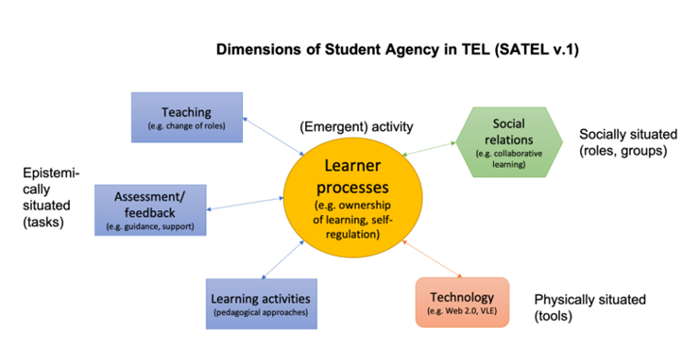

Figure 1. *A model approach to the dimensions of student agency in TEL within higher education*

.

Another study that linked between student agency and technology enhanced learning was conducted by Knight and Barbera (2018). They focused on learner’s agency in Computer-Assisted Language Learning (CALL). Their research result suggests that there is agency, specifically what is called as ‘directional agency’, agency related to navigational acts during language learning tasks (Knight and Barbera 2018).

McLoughlin and Lee in (Marín, Benito, and Darder 2020) suggest that ‘many social software tools afford greater agency to the learner by allowing autonomy and engagement in global communities where ideas are exchanged and knowledge is created as students assume active roles.’ Furthermore, they list several dimensions of agency related to learning: learner autonomy, ownership of learning, self-regulation, learner control, engagement, motivation, reflection on learning, self-directed learning, student participation, logistical choices (technology, place, and time), and other dimensions.

Various studies were conducted to examine student agency in technology-enhanced learning. However, studies on technology-enhanced language learning and how EFL students enact agency are scarcely conducted. Therefore, we focuses our research on the possibility of English Department students taking online courses during the pandemic developing agency. As such, this study aims to answer the

following questions: (1) how online learning during the covid 19 pandemic help promotes students’ agency? (2) how does the portrayal of students’ agency in online learning during the covid 19 pandemic imply to future learning?

**METHOD**

The present study aimed at investigating online learning during the covid 19 pandemic to help promote students’ agency and portraying its implication for future learning. The study employed qualitative design by adopting survey. Its limitation is centred on the issue of learners agency during the covid 19 pandemic based on the data of students learning activities in higher education.

The study was carried out in a state islamic institute in Cirebon. The total number of respondents were 40 students representing students in an academic batch year. There were 8 male students and 38 female students. The students were selected purposively by considering their academic achievement in term of high, average, and low achiever. Another consideration was all of them experienced two years online learning.

The study used online survey as the instrument to collect the data. The questionnaire consisted indicators with 20 items relating to opportunities to make choices, equal treatment, participation, interest and motivation, self efficacy, teacher support, and peer support. The answer of the each item is measured using Likert scale. The survey is distributed via Google form.

The data obtained from the survey were analyzed descriptively and visually to provide more insights on items being studied. To maintain the validity and reliability of the data, member check was employed. A panel discussion among researchers was done to gain the data that fulfill the objectives of the study.

**RESULTS AND DISCUSSION**

This study investigated students’ agency in online learning during the Covid 19 pandemic. It attempted to answers two main questions on how online learning during the covid 19 pandemic helps promote students’ agency and how the portrayal of students’ agency in online learning during the covid 19 pandemic implies to future learning.

**Online learning during the covid 19 pandemic helps promote students’ agency**

To answer the first research question, the results of the survey are explained. The survey consists of 20 statements which belong to 7 agency factors. They include opportunities to make choices, equal treatment, participation, interest and motivation, self-efficacy, teacher support, and peer support. The participants gave their responses by choosing one of the Likert-scale points ranging from 1-4 which indicate Strongly disagree, Disagree, Agree, and Strongly agree respectively. The finding in each factor is described as follows.

1. ***Opportunities to make choices***

The questions about students’ opportunities to make choices are represented in two questions. They include how students choose their learning resources and ways to learn learning materials in online learning during the pandemic. The results are shown in the following figures.

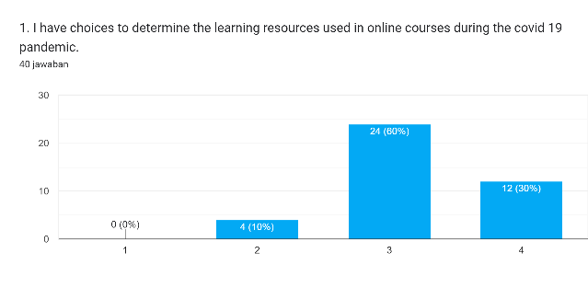

Figure 2. *Students’ choices to determine the online resources*

Figure 1 indicates that most of the students (60%) agreed that they had choices to determine the learning resources used in online courses during the Covid 19 pandemic, whereas very few of them (10%) felt that they did not have the choices. It implies that the availability of abundant resources online eases students’ chances to get learning resources. Besides that, some of the learning resources can be accessed for free, so students will find it easier to expose themselves to the learning resources available.

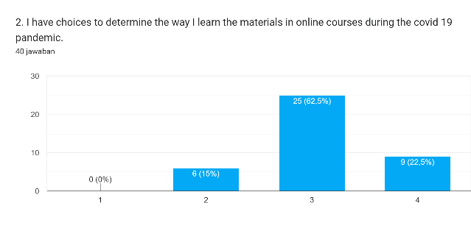

Figure 3. *Students’ choices to determine ways to learn the materials*

Similar to the finding on students’ choices to choose the learning resources, most of the students also agreed that they had choices to determine ways to learn the materials in online courses during the Covid 19 pandemic. In contrast, few students (15%) stated that they did not have choices to decide ways they used to learn the learning materials.

The results of the first two questions indicate that online learning has enabled students to interact easily with plentiful learning resources available online. It goes along with the chances students get to decide ways to earn the materials. In other words, online learning during the pandemic gives students more freedom to choose the learning resources and ways to learn the materials. This is in line with Lebenicnik, et al. (2015) who argue that

varied learning resources that are available online enable students to make the most suitable educational setting for their personalized learning and choices.

1. ***Equal treatment***

In the survey, there is only one question representing the treatment students get in online learning during the pandemic which is about the equal treatment that students get from their lecturers. The result can be seen as follows.

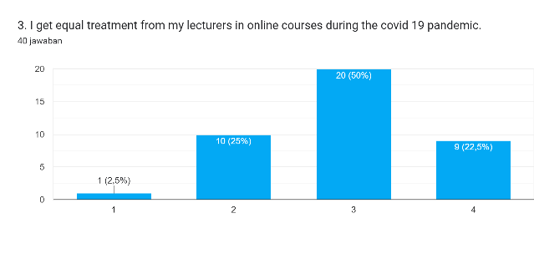

Figure 4. *Lecturers’* e*qual treatment to students*

Figure 3 shows that most of the students (50%) agreed that their lecturers treated them equally in online learning during the pandemic. However, there were few students stated that they were not treated equally by their lecturers. An example of how power relations mediate students’ learning experience can be seen from the students that are not treated equally and not all opinions will receive the same value (Forman & Ansell, 2002; Walkerdine, 1997 as cited in Eteläpelto, et al., 2005).

1. ***Participation***

Four questions were formulated to know students’ participation in online learning during the pandemic. Participation covers students’ chance to ask questions, give opinions, take responsibility by being active participants, have the willingness to participate, and have the courage to express different views.

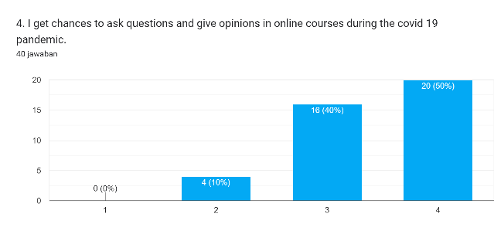

Figure 5. *Students’ chances to ask questions and opinions*

Based on the data above, it can be seen that most of the students (50%) strongly agreed that they had chances to ask questions and give opinions in online courses during the Covid 19 pandemic. Only very few students (10%) disagreed with the statement.

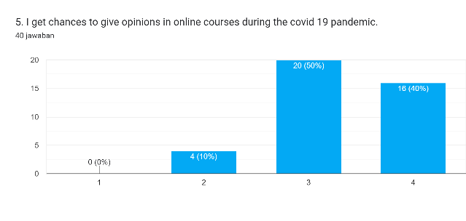

Figure 6. *Students’ chances to ask questions and opinions*

Similar to the responses in the previous statement, the students agreed that they got more chances to share their opinions in online courses during the Covid 19 pandemic. However, the number of students who agreed with the statement is higher than those that strongly agreed with the statement.

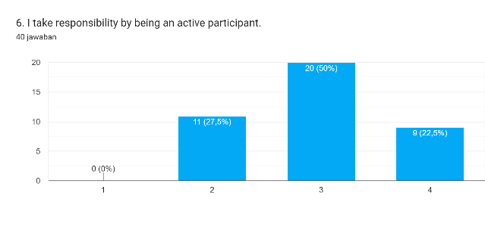

Figure 7. *Students’ responsibility to be active participants*

Figure 5 indicates that most of the students (50%) agreed that they took responsibility by being active participants in online learning. On the contrary, a few students (27.5) argued that they did not take responsibility to be active participants.

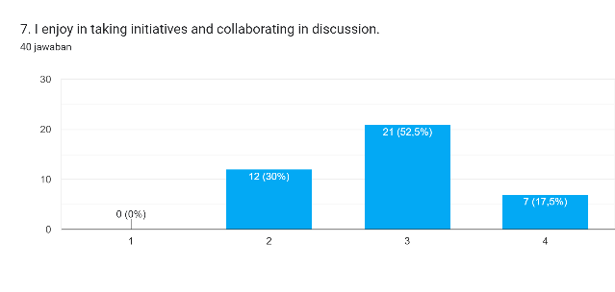

Figure 8. *Students’ pleasure in taking initiative and collaborating in discussion*

The figure above illustrates how students enjoy taking initiative and collaborating in the discussion. Most of the students (52.5%) agreed that they enjoyed taking initiative and collaborating in the discussion, yet a few students (30%) did not enjoy taking the initiative and collaborating in the discussion.

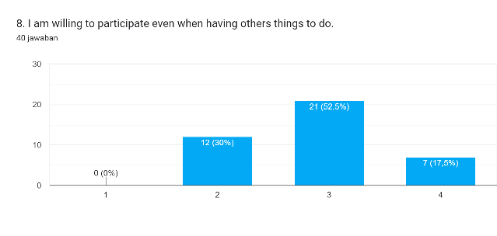

Figure 9. *Students’ pleasure in taking initiative and collaborating in discussion*

In Figure 8, it can be seen that most of the students (52.5%) were willing to participate even when having others things to do. A few of them gave the opposite opinion that when they had other things to do, they were not willing to participate.

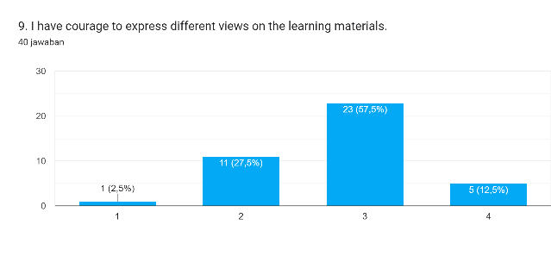

Figure 10. *Students’ courage to express different views on the learning materials*

The figure above reflects that most of the students (57.5%) have the courage to express different views on the learning materials. Nevertheless, a few of the students (27.5%) stated that they did not have the courage to express different views on the learning materials.

The results of the survey on the participation factor indicate that online learning during the pandemic has made it possible for students to get more chances to express their ideas and to contribute more to class discussions. Greeno (as cited in Jääskelä, et al., 2017) points out that students’ changing involvement patterns are thought to affect how they regard themselves as learners, which influences how they take their learning ‘initiative and responsibility’. Despite more chances available, a few students still found it difficult to commit to being active participants, to prioritize the courses, and to contest the learning materials.

1. ***Interest and motivation***

The interest and motivation factor covers 5 important aspects. They include students’ learning motivation, opinions on the course contents, desire to succeed in the course, desire to learn to understand the materials, and persistence in learning.

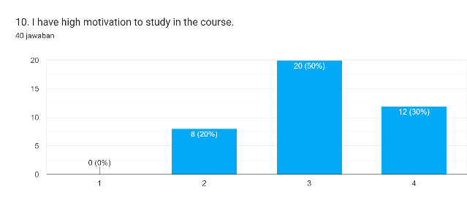

Figure 11. *Students’ motivation to study in the course*

Figure 10 shows that most of the students (50%) found that they were highly motivated to learn online learning during the pandemic. Only 20% of the students responded that they did not have high motivation to study in the course.

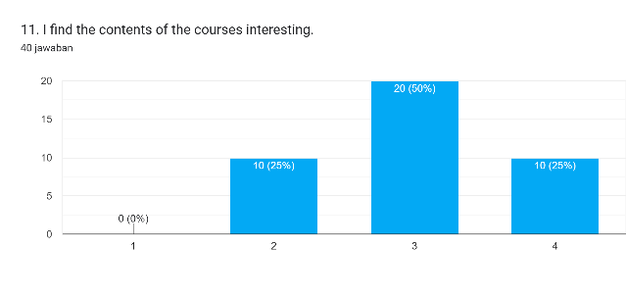

Figure 12. *Students’ opinions on the course contents*

Regarding students’ opinions on the course contents, most of the participants agreed that the contents of the courses were interesting. A few of them, on the other hand, found that the contents of the courses were not interesting for them.

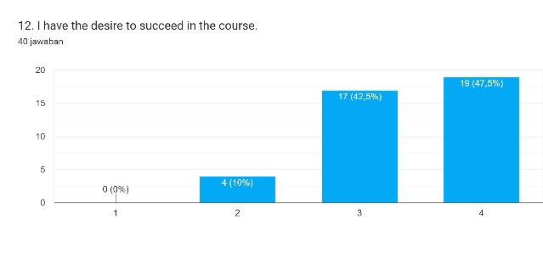

Figure 13. *Students’ desire to succeed in the course*

Figure 12 indicates that most of the students have the desire to succeed in the course. 47.5% of the participants expressed their strong agreement to the statement and 42.5% of the participants justified it by giving their agreement on the same statement

.

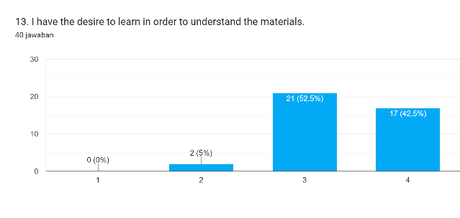

Figure 14. *Students’ desire to learn in order to understand the materials*

In line with the previous statement, students’ desire to learn in order to understand the materials can be seen in Figure 13 above. Most of the participants agreed that they had the desire to learn in order to understand the materials better.

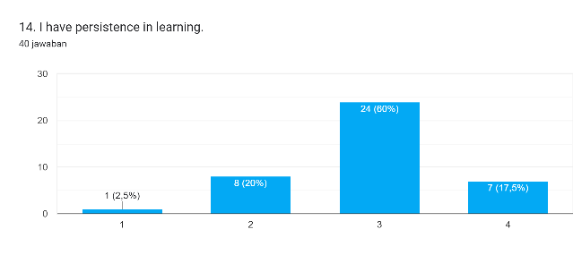

Figure 15. *Students’ persistence in learning*

Figure 14 demonstrates students’ persistence in learning. Most of the students (60%) agreed that they had persistence in online learning during the pandemic.

Online learning during the pandemic can be said to successfully improve students’ interest and motivation in learning. This will lead to their positive views on the learning materials, learning desire, and persistence in learning. A similar idea was stated by Waryanto (as cited in Fajri et al., 2021) that one of the benefits of online learning is it can increase students’ motivation and interest to learn.

1. ***Self-efficacy***

The factor related to students’ self-efficacy is addressed in two statements. They are students’ belief in their competences to succeed in the courses and to complete challenging tasks in the courses.

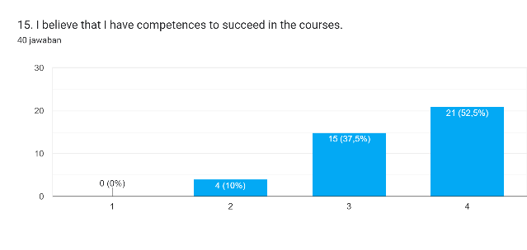

Figure 16. *Students’ belief in their competences to succeed in the courses*

Figure 15 demonstrates that most of the students (52.5%) strongly agreed that they believed they could use their competences to succeed in the courses. Only few students (10%) stating their disagreement on the statement.

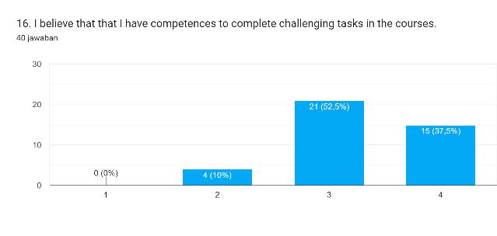

Figure 17. *Students’ belief in their competences to complete challenging tasks in the courses*

Related to the previous statement, students’ beliefs on their competences to complete challenging tasks were also included. The results indicate that most of the students 52.5% believed they could use their competences to complete challenging tasks in the courses.

In addition, if seen from the responses to the two statements regarding students’ self-efficacy, the number of students who disagreed with the statement was the same. It can be implied that those students giving their disagreements are the same. Thus, students’ belief in their competence to succeed in the courses will reflect their efforts in using the competences to complete challenging tasks in the courses. Students’ strong self-efficacy can promote well-being, motivation, and effort devotion. Students that have high self-efficacy are more likely to be happy, motivated, and dedicated to their work (Jääskelä, et al., 2017).

1. ***Teacher support***

The teacher support factor is represented in two statements regarding lecturers’ positive attitudes to the students and students’ experience of being forced by their teachers. The result can be seen in the following figures.

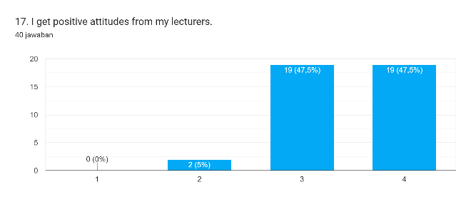

Figure 18. *Lecturers’ positive attitudes to the students*

Figure 17 represents lecturers’ positive attitudes toward the students. Most of the students show positive responses to the statement. The same percentage of the students (47.5%) strongly agreed and agreed with the statement that they got positive attitudes from their lecturers.

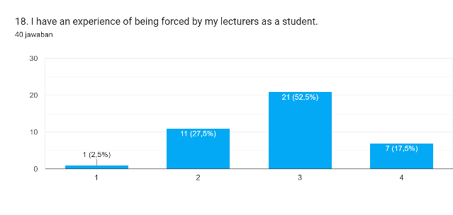

Figure 19. *Students’ experience of being forced by their teachers*

Despite the responses that students got positive attitudes from their lecturers, the responses on students’ experience of being forced by their lecturers indicate that the majority of the students (52.5%) experienced force from their lecturers.

Despite the positive support that students got from the lecturers, the majority of students claimed that they had experiences of being forced by their lecturers. This indicates that students’ learning motivation has not been maintained well. A similar idea is given by Ryan & Deci (2000) stating that individuals’ ‘intrinsic motivation’ is sustained when they have the freedom to voluntarily act on something without any outside pressure.

1. ***Peer support***

Besides peer support, one of the factors in agency also addresses how students support each other’s learning. The statements related to peer support involve students’ learning support from their peer’s experience and students’ reciprocal assistance in dealing with learning difficulties.

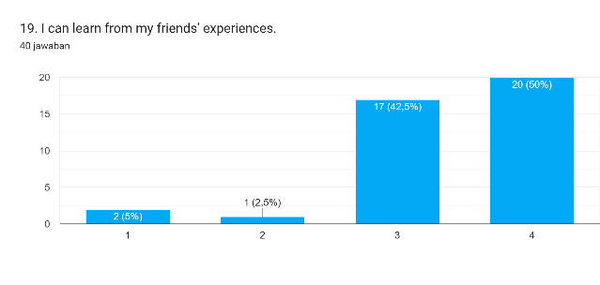

Figure 20. *Students’ learning support from their peers’ experiences*

Figure 19 shows that most of the students (50%) agreed that they could learn from their friends’ experiences. Only very few students showed their disagreement to the statement.

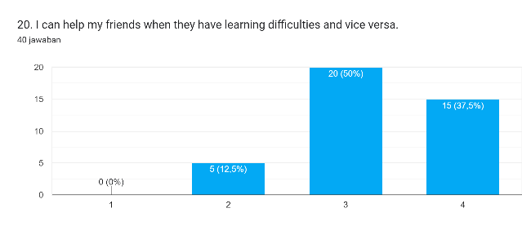

Figure 21. *Students’ reciprocal assistance in dealing with learning difficulties*

The data in Figure 20 show that most of the students (50%) agreed that they gave reciprocal assistance in dealing with each other’s learning difficulties. It implies that in online learning where students cannot involve in face-to-face interaction, they can still help each other’s learning difficulties. To practice agency, teacher-students’ and students-students’ mutual relationships and students’ ability to collaborate are the key components (Greeno; Lipponen and Kumpulainen; Edward as cited in Jääskelä, et al. 2017; Eteläpelto, et al., 2005).

In conclusion, online learning during the pandemic has given students more authority to develop their agency. The survey results indicate that most of the students gave positive responses to the statements regarding agency factors which include opportunities to make choices, equal treatment, participation, interest and motivation, self-efficacy, teacher support, and peer support. In addition, the results also show that there are interrelated relationships between one factor of agency and another. For example, the students who feel that they are given more opportunities to make choices and teacher support in the learning process will be more motivated to learn and more confident to use their competences to take initiative and be active in the teaching and learning process. However, to achieve a fruitful result, thorough development of agency domains by accommodating all related factors should be done. The survey results show that even if the lecturers already have provided more choices for students in learning when students still feel they are oppressed in the learning process it shows that the students have not fully developed their agency and their motivation may not be maintained well. “In sum, these conceptualisations of agency emphasise individuals’ capability to engage in intentional, self-defined, meaningful and autonomous action which is constrained by power relations and structural, contextual factors” (Jääskelä, et al., 2017). Online learning during the pandemic which creates a learning environment for students that enable them to express their preferences and actions to deal with their own learning problems and goals can promote students’ agency.

**The implication of the portrayal of students’ agency in online learning during the covid 19 pandemic to future learning**

The portrayal of students’ agency in online learning during the covid 19 pandemic described above can provide some implications for future learning. Each implication will be explained as follows.

Students can be successful learners if they can develop their agency. Students’ agency will help them be able to identify their learning problems, competences, learning goals, and develop self-regulated learning so they can successfully achieve their learning goals. Nowadays, the focus of higher education curriculum is increasingly given to developing students’ abilities to create their own learning environment, as well as their capacity for self-regulation, goal-setting, and accepting responsibility (Lebenicnik, et al., 2015).

To develop the agency, the teaching and learning process should not only focus on the mastery of content knowledge. Lecturers should also give students chances to discover and develop their agency. Students' agency can be developed in the learning atmosphere that provides chances for students to participate, influence others, and recognize their own strengths, preferences, objectives, and possessions to develop their identities as learners and future professionals (Marin et al., 2020).

In addition, one of the domains of agency is relational agency. It concerns how the power relations between the teacher and students are maintained. The power relations do not only deal with teacher-student relationships but also students’ mutual relationships. Therefore, giving more chances for students to make choices is not enough, lecturers should be able to minimize force on students. This can be done by developing the agency itself. By helping them develop their agency, students will be willing to contribute to the teaching and learning process and oppression can be eliminated. Thus, lecturers must create a learning atmosphere which enable students to develop their agency. Lipponen & Kumpulainen (as cited in Marin, et.al, 2020) state that teachers are in greater need of relational agency which is connected to their ability to work together and give mutual assistance to each other.

Last but not least, since the participants of this study were teacher candidates, developing teacher candidates’ agency will be valuable, so in the future, they can be role models for their students to share their experiences in developing their agency. The most essential thing in the initial stage of teacher education is to develop teacher candidates’ agency (Marin, et.al, 2020). Regarding changes in education, agentic teachers play an important role since agency deals with how one responds to challenging conditions (Biesta, et al., 2015).

**CONCLUSION**

The self-reported questionnaire results suggest that the online learning relying heavily on the Internet and digital technologies during the Covid 19 pandemic encouraged students to develop a sense of agency. Most students perceived that they were given choices to determine ways of learning and which learning resources they wanted to use. This is an important indicator of student agency because at the heart of agency is the ability to make choices. The research results also suggest that online courses provided chances for students to participate, receive equal treatment, influence others, and receive supports from peers and lecturers. In order for online courses to be able to promote student agency, the courses should encourage students to take the responsibility of their own learning, to determine their goals, to recognize their own strengths, preferences, as well as to develop their identities as learners and future professionals

**REFERENCES**

Ahearn, Laura M. 2001. “Language and Agency.” *Annual Review of Anthropology* 30. doi: 10.1146/annurev.anthro.30.1.109.

Ali, Wahab. 2020. “Online and Remote Learning in Higher Education Institutes: A Necessity in Light of COVID-19 Pandemic.” *Higher Education Studies* 10(3). doi: 10.5539/hes.v10n3p16.

Bandele, O. S., and A. .. Farem. 2012. “An Investigation into the Challenges Facing the Implementation of Technical College Curriculum in South West, Nigeria.” *Journal of Education and Practice* 3(12).

Biesta, G., Priestley, M., & Robinson, S. (2015). The role of beliefs in teacher agency. *Teachers and Teaching,* *21*(6), 624–640.

Bimrose, Jenny, and Lucy Hearne. 2012. “Resilience and Career Adaptability: Qualitative Studies of Adult Career Counseling.” *Journal of Vocational Behavior* 81(3). doi: 10.1016/j.jvb.2012.08.002.

Bush, Lee, Daniel Haygood, and Harold Vincent. 2017. “Student-Run Communications Agencies: Providing Students with Real-World Experiences That Impact Their Careers.” *Journalism and Mass Communication Educator* 72(4). doi: 10.1177/1077695816673254.

Eteläpelto, A., Littleton, K., Lahti, J., & Wirtanen, S. (2005). Students’ accounts of their participation in an intensive long-term learning community. *International Journal of Educational Research*, *43*(3), 183–207.

Fajri, Z., Baharun, H., Muali, C., Shofiatun, Farida, L., & Wahyuningtiyas, Y. (2021). Student’s Learning Motivation and Interest; the Effectiveness of Online Learning during COVID-19 Pandemic. *Journal of Physics: Conference Series*, *1899*(1). https://doi.org/10.1088/1742-6596/1899/1/012178

Ghafar, Abdul. 2020. “Convergence between 21st Century Skills and Entrepreneurship Education in Higher Education Institutes.” *International Journal of Higher Education* 9(1). doi: 10.5430/ijhe.v9n1p218.

Grainger, Peter, Robert Steffler, Margarietha J. de Villiers Scheepers, Catherine Thiele, and Shelley Dole. 2019. “Student Negotiated Learning, Student Agency and General Capabilities in the 21st Century: The DeLorean Project.” *Australian Educational Researcher* 46(3). doi: 10.1007/s13384-018-0287-6.

Jääskelä, Päivikki, Anna Maija Poikkeus, Kati Vasalampi, Ulla Maija Valleala, and Helena Rasku-Puttonen. 2017. “Assessing Agency of University Students: Validation of the AUS Scale.” *Studies in Higher Education* 42(11). doi: 10.1080/03075079.2015.1130693.

Jiang, Anne Li, and Lawrence Jun Zhang. 2019. “Chinese Students’ Perceptions of English Learning Affordances and Their Agency in an English-Medium Instruction Classroom Context.” *Language and Education* 33(4). doi: 10.1080/09500782.2019.1578789.

Knight, Janine, and Elena Barbera. 2018. “Navigational Acts and Discourse: Fostering Learner Agency in Computer-Assisted Language Learning.” *Electronic Journal of E-Learning* 16(1).

Lebenicnik, M., Pitt, I., & Istenic Starcic, A. (2015). (2015). Use of online learning resources in the development of learning environments at the intersection of formal and informal learning: The student as autonomous designer. *CEPS Journal*, *15*(2), 95–113.

van Laar, Ester, Alexander J. A. M. van Deursen, Jan A. G. M. van Dijk, and Jos de Haan. 2017. “The Relation between 21st-Century Skills and Digital Skills: A Systematic Literature Review.” *Computers in Human Behavior* 72. doi: 10.1016/j.chb.2017.03.010.

Marín, Victoria I., Bárbara de Benito, and Antònia Darder. 2020. “Technology-Enhanced Learning for Student Agency in Higher Education: A Systematic Literature Review.” *Interaction Design and Architecture(S)* 45:15–49. doi: 10.55612/s-5002-045-001.

Martel, Jennifer Saray Santana, and Adolfina Perez Garcías. 2022. “Students’ Agency and Self-Regulated Skills through the Lenses of Assessment Co-Creation in Post-COVID-19 Online and Blended Settings: A Multi-Case Study.” *Journal of Interactive Media in Education* 2022(1):1–17. doi: 10.5334/jime.746.

Okolie, Ugochukwu Chinonso, Hyginus Emeka Nwosu, and Sunday Mlanga. 2019. “Graduate Employability: How the Higher Education Institutions Can Meet the Demand of the Labour Market.” *Higher Education, Skills and Work-Based Learning* 9(4). doi: 10.1108/HESWBL-09-2018-0089.

Patricia Aguilera-Hermida, A. 2020. “College Students’ Use and Acceptance of Emergency Online Learning Due to COVID-19.” *International Journal of Educational Research Open* 1. doi: 10.1016/j.ijedro.2020.100011.

Ryan, R. M., & Deci, E. L. (2000). Intrinsic and extrinsic motivations: Classic definitions and new directions. *Contemporary Educational Psychology*, *25*(1), 54–67.

Yavani, Zakky, Haira Rizka, Muhsiyana Aisyiyah, and Nizar Ibnus. 2022. “What Will The Future Bring? Students’ Gender-Based Participation During Online Classes.”