Top margin : 2.5 cm Bottom margin : 2 cm Right margin : 2.5 cm Left margin : 2 cm
SEMIOTIC ANALYSIS OF COVID-19 MEME IN SOCIAL MEDIA
Sri Kurniati Almucharomah¹, Wening Sahayu², Sulis Triono³
Universitas Negeri Yogyakarta, Indonesia
uniealmucharomah@outlook.com, weningsahayu@uny.ac.id, sulis@uny.ac.id
APA Citation: Baker, R. A. (2018). Article’s title. English Review: Journal of English Education, 6(2), 1-10. doi: 10.25134/erjee.v6i2.1238.
Received: 14-02-2018 Accepted: 23-04-2018 Published: 01-06-2018
Abstract: The presence of social media makes the process of social interaction experience very significant changes. Communication through social media is a very important social interaction in human life. Along with the increasing use of social media, it has spawned new phenomena among social media users, one of which is creativity in making memes. Memes can be in the form of text or images that contain issues and events in a style that intrigues and are widely discussed because they spread and comment so quickly on social media. The purpose of this study is to describe the signifier and signified in the Covid-19 meme and explain the meaning contained in the Covid-19 meme. The Covid-19 meme itself is one of the memes found on social media. The approach used in this research is a qualitative approach which produces descriptive analysis. The researcher tries to describe the facts behind the creation of the Covid-19 meme circulating on social media. The signifiers found in the Covid-19 meme include snippets of famous movie and game scenes. The insinuations in the sentences are also very true to reality. The sentences provide a statement that contains information and there is an expression of the feelings of the creator as a fighter in the pandemic season.
Keywords: semiotics, memes, Covid-19
INTRODUCTION
Today, in which people use the internet as the biggest social media and it has various functions. Social media is not only for entertainment which is lifestyle and music, but also as a medium to show daily life, express feelings, and also to criticize today’s social phenomena. According to (Junawan & Laugu, 2020) social media is one of the fastest-growing media. Around 70% of internet users in the whole world are also active on social media. Social media such as Facebook dan Twitter, up until now still has a high level of users.
Recently, the development of information and communication technology has been growing rapidly. This certainly affects the lifestyle of humans in general. In the past, humans did not know the internet and now information can easily be obtained through the internet. In the past, humans only knew SMS as a means of sending short messages and now there are so many platforms for sending short messages, for example, Whatsapp, Line, Telegram, Wechat, and so on. Even today the development of social media is increasingly unstoppable, such as Facebook, Instagram, Twitter, Pinterest, LinkedIn, Tumblr, TikTok, and more.
Social media development today has become a necessity for human beings and can change a life. Many people are active on social media. They can spend hours surfing social media. This phenomenon is evidence that today people are very dependent on social media. The advantage of social media is the designs which are easy to use and have various features, such as can upload photos and videos, also send short messages via DM or Direct Message and Inbox.
In this era of globalization, it is not strange to do various activities using a computer, both for doing assignments and even socializing on social media such as Facebook, Instagram, Twitter, TikTok, and others. This advancement shows that communication and access to information are necessities that cannot be separated from people's lives. Social media is very commonly used by Indonesian people. Various kinds of social media in the form of applications can be downloaded easily on every smartphone, making it easier for users to interact on the social media they have, starting from chatting, updating status, updating photos or pictures, and so on. One of the activities on social media that is currently popular in society is spreading various meme images. Opinion (Dewi Surya, 2019) about a meme is one of the works of art that lately has been very lively raised by netizens on social media. In the digital era circulating memes are no longer understood as limited to small units of culture that are spread from person to person by copying or imitation, but now the term meme refers to the replication of a person's photo or image which is changed to another form, coupled with various written usually satire or joke via Windows (and other operating systems) from internet users. Memes can develop through imitation by humans according to the ideas stored in the brain and spread by the process of imitation and posting by netizens.
The presence of social media makes the process of community social interaction experience very significant changes. Communication through social media is a very important social interaction in human life. Through this communication, humans can exchange messages and information. Along with the increasing use of social media, it has spawned new phenomena among social media users, one of which is creativity in making memes. Memes can be in the form of text or images that contain issues and events in a style that intrigues and becomes a hot topic of discussion because they spread and comment so quickly on social media (Woods & Hahner, 2019). Memes contain entertaining social messages, parodies, and satire. A meme is one of the phenomena of conveying messages in a new form by combining verbal language with nonverbal communication (expression).
The term 'meme' was first coined by Richard Dawkins, an evolutionary biologist. The meme comes from the Greek, mimeme which means imitation. Said by (Milner, 2018) that memes are message-sending units and cultural imitation units that circulate from one human to another. Memes and genes evolve together. However, human culture evolves faster than human genes. The unit for sending this message can be in the form of a song, fashion style, architecture, to the concept of divinity. Messaging units proliferate from generation to generation. Memes can be in the form of movies, videos, pictures, or just words or expressions. Apart from that, some creators create memes by combining several things, such as images accompanying text, while there are images adapted to video games, movies, celebrities, and the world of politics.
The strength of a meme lies in the creativity of the creator in combining text, images, videos, graphics, and various content so that it is easy for readers to understand. (Osterroth, 2020) gave opinion that ein Mem kann beispielsweise ein Bild oder ein Video sein, eine Phrase, ein längerer Text, ein Dialogschema, ein Textstruktur oder ein immer wieder eingesetzter Rechtschreibfehler sein, im Grunde kann alles, was imitiert und vaiiriert werden kann, zum Mem werden. Memes according to (Osterroth, 2020) can be in the form of pictures or videos, phrases, longer texts, dialogue schemes, text structures, or spelling errors that are repeatedly used; anything that can be imitated and varied can become a meme.
There are so many memes circulating on social media, one of which is the meme about Covid-19 that is sweeping the world. Covid-19 is caused by a virus and is one of the worst pandemics in human history with such a high death rate. The Covid-19 virus outbreak occurred in early 2020. The virus then spread throughout the world. Since January 2020 WHO has declared that the world is experiencing a global pandemic emergency with the Covid-19 virus. The Covid-19 pandemic has caused a change in lifestyle in the world community so many people are not prepared to adapt. This is the main cause of anxiety, stress, and panic among some people. Anxiety that arises varies, such as anxiety about contracting the Covid-19 virus, anxiety about weakening or even worsening financial conditions, and anxiety about the future after the pandemic is done (Kamil et al., 2020).
Recent research shows that viewing funny memes can help people feel calmer and deal with stress due to the pandemic. There are lots of funny memes circulating on social media, so this meme can be used to help relieve stress during the Covid-19 pandemic. This is in line with the opinion (Myrick et al., 2022) and (Valenzuela & Batinga, 2021) that simply viewing memes can help people cope with the pressures of living during a global pandemic. In addition, people who see memes related to Covid-19 feel comfortable and more confident in their ability to overcome this pandemic.
The unique and intriguing characters of the memes that are spread on social media raise the question: what is the actual intention and purpose of the images, writings, or scenes of the characters contained in these memes? To answer this question, this study wants to observe and analyze the use of memes using Roland Barthes' semiotic analysis, which aims to describe the signifiers and signifieds in the Covid-19 meme and explain the meaning contained in these memes. Many Covid-19 memes are circulating on social media.
Semiotics is a science or analytical method that examines signs. A sign is a symbol in the form of a clue to tell someone in search of an answer to that sign. In terms of (Compagno, 2018) semiotics is semiology, namely reconstruction that focuses more on the system of sign meanings than on language that specifically applies to structural activities according to the process. Semiotics is a scientific study or analytical method to examine signs in the context of scenarios, images, texts, and scenes in films that can be interpreted. Meaning means that objects do not only carry information, in this case, the objects want to communicate, but also constitute a structured system of signs used. Barthes' semiotic analysis refers to a sign system that generates meaning that will describe the meaning of denotation, connotation, and myth in several Covid-19 memes on social media.
METHOD
Qualitative research was used in this research. (Moleong, 2017) explained that qualitative research is research to understand the phenomenon of what is experienced by research subjects as a whole using descriptions in the form of words and language, in the specific context experienced, and by utilizing various scientific methods. Qualitative research aims to produce descriptive analysis. The researcher tries to describe the facts behind the making of the Covid-19 meme circulating on social media.
Data collection techniques were carried out using library research and documentation. A literature study is a data collection technique by conducting a review study of books, literature, records, and reports that have something to do with the problem being solved (Pandey & Pandey, 2021). Literature and documentation studies are carried out by selecting and collecting data by downloading and capturing screenshots of memes shared on social media and analyzing them.
The semiotic approach is qualitative-interpretive namely, a method that focuses on signs and texts as their study, as well as how researchers interpret and decode texts and signs themselves. Semiotics plays its role in every sign system, regardless of its substance and boundaries; images, gestures, tones, sounds, music, objects, settings, and even combinations of these, which form both conventional and contemporary entertainment content.
Semiotics is applied as a method to approach texts in the media with the assumption that the media itself is communicated through the sign elements it carries. The signs carried in the media are also loaded with certain interests which shows their complexity because signs in the media certainly never carry a single meaning (Widiastuti et al., 2020). The semiotic tradition consists of a set of theories about how signs represent ideas, situations, feelings, materials, and conditions beyond the signs themselves. Semiotic analysis is a method or way to analyze and give meaning to signs and objects contained in messages or texts. As a method of analysis, semiotics is one of the most interpretive methods in analyzing a text and its success or failure as a method rests on how well researchers can articulate the cases they study.
RESULTS AND DISCUSSION
Semiotics is a science that studies signs. If related to memes, semiotics studies the function of image signs, namely how to understand the sign system that exists in memes that play a role in guiding readers to be able to capture the messages contained in them. Humans can only think and communicate using signs. The sign in question can be a visual sign that is non-verbal or verbal in nature.
Semiotics is the theory of analysis of various signs and meanings. How to interpret and examine the operation of a sign in forming a unity of meaning or signification. Semiotics analyzes a text or image to obtain information. The study of semiotics considers that social phenomena in society and culture are signs. Semiotics studies systems, objects, and events that allow the sign to have meaning. According to (Van Wolde, 2018) semiotics is a science or method of analysis to study signs. Signs are tools that we use in trying to find our way in the world, among humans, and with humans. Semiotics or in terms of Barthes semiology wants to study how humanity makes sense of things. Interpreting (tosinify) in this case cannot be confused with communicating (to communicate).
The results of this study are divided into two main parts, namely describing the Covid-19 meme markers and explaining the analysis and description of the types of semiotic markers that appear in the Covid-19 memes. In this study, there are 10 memes, each of which describes how difficult it is to face the Covid-19 pandemic. The following will describe the results of the analysis of the data obtained.

Data | Sign  (Signified) | Marker  (Signifier) | Translation | Symbol Meaning | Type of Sentence
1. | A woman dancing to striptease wearing full PPE. | 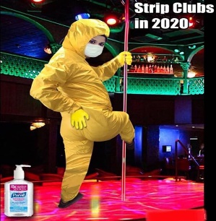 | Strip Club in 2020. | The first data indicates that during a pandemic situation, Striptease dancers also wore full PPE clothing when dancing at Strip Clubs. | From the syntactic point of view, it can be seen that the writing on the meme is made as 'satire'. The clothes of the Striptease dancers are similar to bikinis because, at this time of the Covid-19 pandemic, the image of the dancers is wearing full PPE
2. | A woman is taking food or drinks in the refrigerator which is located in the kitchen. | 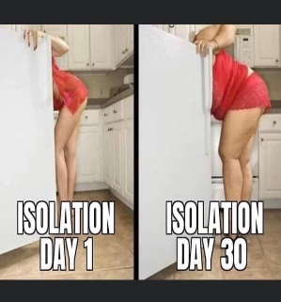 | First day of isolation. 30th day of isolation. | The second data marker is when the woman self-isolates during the pandemic, on the first day the woman's body is still slender, and on the 30th day of independent isolation, the woman's body becomes fat because she eats too much and does not do enough exercise. | Judging from the syntax, when people do isolation, they will gain weight after they finish isolating. This is because during isolation people go to the kitchen more often than usual, including checking the fridge and cupboards. They don't feel they put food in their mouths until they spend a lot of food.
3. | A giraffe in the meadow. | 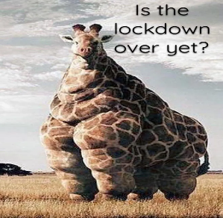 | Is the lockdown over? | The third data marker, namely that a giraffe became very fat after the lockdown ended, is the third image marker. | Through the syntax, it can be seen that during the lockdown, people rarely did activities outside the home. This causes them to feel anxious, depressed, and lonely, resulting in an increased appetite and resulting in weight gain.
4. | Picture of a toddler laughing and crying. | 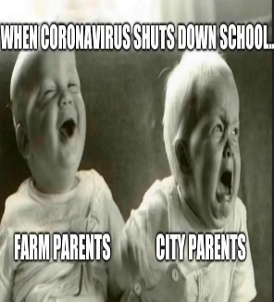 | When the coronavirus closes all school activities. Parents in the countryside and the city. | The fourth data marker is that during the Covid-19 pandemic, many schools closed and carried out distance learning. Parents of students who live in rural areas are certainly very happy because their children do not need to go to school and can help with their work, while parents who live in urban areas feel very sad because their children are just playing. | In terms of syntax, people living in rural areas are better than those living in cities. In villages, the spread of Covid-19 is lower considering that there are rarely gathering points for the community, whereas in cities there are many shopping centers and cinemas, so people gather more often so the spread of Covid-19 becomes faster. The people in the village can still work in the fields or the garden, so they are happier. During a pandemic, people who live in cities work from home and are prohibited from doing activities outside the home, so many of them feel stressed and depressed.
5. | Toddlers sitting on the floor of their house without clothes. | 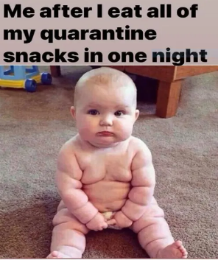 | Me after I ate all my quarantine snacks in one night. | The fifth data indicates that during the quarantine period, you are required to eat a lot to maintain the body's immunity. As a result, the weight increases. | In terms of syntax, it can be seen that during quarantine, it is easier for people to give up good habits, such as sports because the pandemic depression does not end soon. As a result, people eat more, and eventually, the scale needle tilts more to the right.
6. | Bigfoot in a scene from the GTA game. | 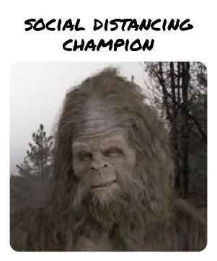 | Social distancing champion. | The sixth data marker is that during a pandemic social distancing was enforced so that people in their activities always keep their distance from other people. This causes people to feel like they are not being cared for because they keep their distance from other people. | From a syntactic point of view, social distancing is very necessary during a pandemic, namely to reduce the risk of transmission of the Covid-19 virus. Social distancing does not mean anti-social, so you look shabby and unkempt.
7. | Birds are looking for food on the edge of the lake. | 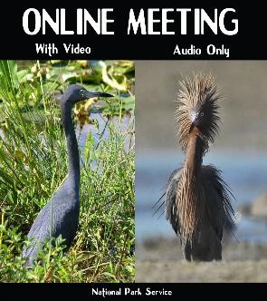 | Online meeting. With videos. Only with audio. | The seventh data marker is that when holding online meetings or online lectures, sometimes people will look sober when they close the camera in an online application and will look neat when they turn on the camera. | From the syntactic point of view, when conducting online meetings, most people will look neat when they turn on the camera and will look sober when they don't turn on the camera. This often happens to people during a pandemic.
8. | Two actors are doing a scene in the movie Back to the Future. | 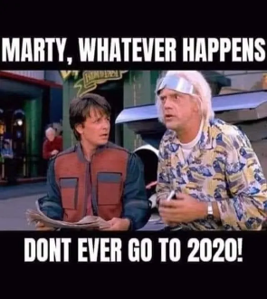 | Marty, no matter what, never Return to 2020! | The eighth data indicates that 2020 was a very difficult year because that year the Coronavirus first appeared which caused a change in the lifestyle of the world community so people did not want to return to 2020. | In terms of syntax, it can be seen that people generally do not want to return to 2020, because that year was the worst in world history. In 2020 many people died due to Covid-19 and the economy collapsed and many people lost their jobs.
9. | A mother with her three children in a room. | 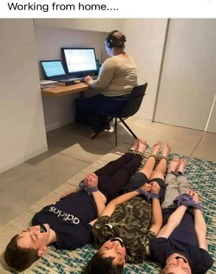 | Work from home. | The ninth data marker is usually when working from home there are lots of distractions. This mother was working from home and her three children were always noisy, in the end, the children were bound hand and foot, and their mouths were covered with plaster. | In terms of syntax, it can be seen that when working from home you will encounter many distractions, including children who ask to play together or who are noisy with their brothers or sisters. To deal with this disturbance, a mother finally decided to tie her children's feet and hands.
10. | A man and dog are watching something. | 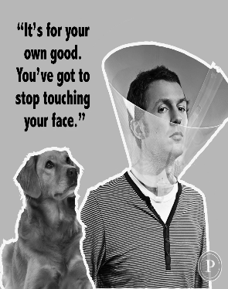 | That is for your good. You must stop touching your face. | The tenth data marker is a dog and its owner who wears a face shield, so that their hands don't touch their faces too often, considering that hands are a source of germs. | The syntactical aspect explains that during the pandemic season, washing hands is very mandatory, to prevent infection with the Coronavirus in yourself, your family, and those around you.

The existence of social media in people's lives makes social media a place to express opinions. Nowadays, people often post various meme images, words, and even hashtags on their respective social media in expressing their views on Covid-19. On social media such as Facebook, Instagram, and Twitter, a meme can be replicated by someone and they can edit it according to the message they want to convey and then upload it to cyberspace. With a process like this, memes have become a means of exchanging ideas, discourse, and information that can be used by anyone. Apart from that, memes are also a means of entertainment, and the functions of memes vary, from wanting attention, sharing ideas, using memes to comment on/quip something, or can influence someone’s mind.
Based on the memes above, it can be seen that in the first meme, there is a meme of a woman dancing to Striptease wearing full PPE clothes which has meaning during a pandemic situation, Striptease dancers also wear full PPE clothes when dancing in Strip Clubs. In the second meme, a woman is taking food or drink from the refrigerator which is located in the kitchen and has meaning when the woman is self-isolating during a pandemic, on the first day the woman's body is still slender, and on the 30th day of independent isolation, the woman's body becomes fat because too much to eat and lack of sports activities. In the third meme, a giraffe in the meadow which has the meaning that a giraffe gets very fat after the lockdown is over is the marker of the third meme.
The fourth meme, the meme of toddlers laughing and crying, means that during the Covid-19 pandemic, many schools were closed and carried out distance learning. Parents of students who live in rural areas are certainly very happy because their children do not need to go to school and can help with their work, while parents who live in urban areas feel very sad because their children are just playing. In the fifth meme, there is a toddler meme sitting on the floor of his house without wearing clothes, which means that during quarantine you are required to eat a lot to maintain your body's immunity. As a result, the weight is increasing day by day.
In the sixth meme, there is a Bigfoot meme in a scene in the GTA game which means that during the pandemic, social distancing was enforced, so that people in their activities always kept their distance from other people. This causes people to feel like they are not being cared for because they keep their distance from other people. In the seventh meme, there is a meme of a bird looking for food by the lake, which means that when conducting online meetings or online lectures, sometimes people will look sober when they close the camera on an online application and will look neat when they turn on the camera. In the eighth meme, there is a picture of two actors doing a scene in the movie Back to the Future, which means that 2020 is a very tough year because that year the Coronavirus first appeared which caused a change in the lifestyle of the world's people, so people don't want to go back to 2020. In the ninth meme, there is a meme of a mother with her three children in a room, and it has the meaning that usually when working from home there are lots of distractions. This mother was working from home and her three children were always noisy, in the end, the children were bound hand and foot, and their mouths were covered with plaster. Of course, this was not intended to hurt his children, but only to teach them a lesson so that later when the mother is working from home, they will not do the same commotion again.
From this research, it can be seen that the Covid-19 memes were made by creators with a specific purpose. The signs used, the choice of diction used, the aesthetics of the images chosen, and the strings of sentences used are carefully thought out so that the goals intended by the creators can be achieved. In general, Covid-19 memes aim to help relieve stress during the Covid-19 pandemic. Seeing funny memes that are spreading on social media can help someone feel calmer and overcome depression due to the pandemic that has hit. The emotional level becomes lower by viewing memes.
Signified which is used in the Covid-19 meme is very easy to understand and interesting according to the intended signifier. The signifiers underlying the Covid-19 meme include scenes from the famous movie Back to the Future and scenes from the GTA game. The words contained in the meme describe various kinds of satire during the pandemic because many people are struggling and surviving during the pandemic. A signified that is made is equipped with a sentence as a sign. The contents of the signified Covid-19 meme can represent the feelings of someone who is facing a pandemic so that the message that the creator hopes for can be conveyed to the reader. In addition, in terms of sentences, the Covid-19 meme contains sentences containing information and expressions of feelings.
The development of internet technology is increasingly advanced, now people can communicate quickly with the help of the internet without having to meet face to face, especially through social media. For memes, communication is a way to expand itself toward other thoughts. Conditions like this eventually paved the way for memes to grow, shifting from conventional ways of communication to more advanced ways by updating themselves to become internet memes. An internet meme is something that becomes famous through the internet. Like pictures, videos, or even people. Internet memes are created through a process of imitation and photographic modification of existing ones. Creators must be observant in observing social events that are currently happening in society. Foresight is needed to find small things that can be used as objects. It is done so that the messages conveyed by internet meme creators to internet meme connoisseurs can be conveyed in entertaining and effective ways.
CONCLUSION
Signifiers found in meme Covid-19 such: there are snippets of famous movie scenes and games. The insinuations in the sentences are also very true to reality. The sentences provide statements that contain information and contain expressions of feelings from creators as fighters during the global Covid-19 pandemic.
REFERENCES
Compagno, D. (2018). Quantitative semiotic analysis. Springer.
Dewi Surya, R. (2019). “Meme” Sebagai Sebuah Pesan Dan Bentuk Hiperrealitas Di Media Sosial. Mediakom : Jurnal Ilmu Komunikasi, 1(1).
Junawan, H., & Laugu, N. (2020). Eksistensi media sosial, Youtube, Instagram dan WhatsApp ditengah pandemi covid-19 dikalangan masyarakat virtual Indonesia. Baitul’Ulum: Jurnal Ilmu Perpustakaan Dan Informasi, 41–57.
Kamil, Isnawan, L., Sukma, H., Rahma, F., Sartika, D., Muliati, Zulkarnaen, D., Devilsa Octavia, Kharisma Selvi, L., Sahirah, Dewintara, E., Muchtar, Nursabah Fatimah, S., Hariyanto, Hasyim, M., Emi Fadillah Putri, N. M., Hafsah, Aeni, N., Nurwina, & Kurniawan Samad, Imam Sari, N. (2020). Bersama Melawan Covid 19. IAIN Parepare Nusantara Press.
Milner, R. M. (2018). The world made meme: Public conversations and participatory media. mit Press.
Moleong, L. J. (2017). Metode Penelitian Kualitatif. Remaja Rosdakarya.
Myrick, J. G., Nabi, R. L., & Eng, N. J. (2022). Consuming Memes During the COVID Pandemic: Effects of Memes and Meme Type on COVID-Related Stress and Coping Efficacy. Psychology of Popular Media, 11(3), 316–323. https://doi.org/10.1037/ppm0000371
Osterroth, A. (2020). Internet-Memes als multimodale Sprechakte in öffentlichen Diskursen anhand von Beispielen aus Antwortthreads von@ realDonaldTrump. Linguistik Online, 101(1), 115–137.
Pandey, P., & Pandey, M. M. (2021). Research methodology tools and techniques. Bridge Center.
Valenzuela, C. L., & Batinga, E. M. (2021). Memeiology: A Content Analysis on the Viral COVID-19 Memes. Available at SSRN 4166456.
Van Wolde, E. (2018). A semiotic analysis of Genesis 2-3: a semiotic theory and method of analysis applied to the story of the Garden of Eden. Brill.
Widiastuti, A., Ismail, M. R., & Iswanto, A. Z. (2020). Analisis Semiotika Meme ‘Profesi yang tidak Dapat Work From Home’selama Pandemi COVID-19. SEMIOTIKA: Jurnal Komunikasi, 14(1).
Woods, H. S., & Hahner, L. A. (2019). Make America meme again: The rhetoric of the Alt-right. Peter Lang New York.

