Instrumen Pengumpulan Data Analisis Kebutuhan
dalam Rangka Penyusunan Tesis
“Kamus Digital Berbasis Budaya Indonesia untuk Pembelajaran BIPA”

Instrument of Need Analysis Data Collection
For Thesis Preparation
“Indonesian Culture-Based Digital Dictionary for BIPA Learning”

Identitas (Personal Identity):
- Nama (Name) :
- Usia (Age) :
- Jenis Kelamin (Sex) :
- Asal Negara (Origin) :
- Bahasa Ibu (First Language/Mother Tongue) :
- Pendidikan (Education) :
No. | Aspek yang Diamati (Aspects Observed)
1. | Apa alasan Anda tinggal di Indonesia? (What is your reason for living in Indonesia?)  - Pekerjaan (employment)  - Sekolah (education)  - Berlibur (holiday)  - …
2. | Sudah berapa lama Anda tinggal di Indonesia? (How long have you lived in Indonesia?)  - 1 minggu (a week)  - 1 bulan (a month)  - 6 bulan (6 months)  - ...
3. | Berapa lama Anda akan tinggal di Indonesia? (How long will you stay in Indonesia?)  - 6 bulan (6 months)  - 1 tahun (a year)  - 2 tahun (2 years)  - …
4. | - Apakah Anda mengalami culture shock ketika tinggal di Indonesia? Ceritakan pengalaman Anda! (Did you experience culture shock while living in Indonesia? Tell us about your experience!)  - Bagaimana cara Anda mengatasinya? (How did you handle it)
5. | Apa tujuan Anda mempelajari bahasa Indonesia? (What is your goal in learning Indonesian?)  - Keinginan untuk mengerti bahasa Indonesia (Desire to understand Indonesian)  - Kebutuhan pekerjaan atau sekolah (Need for work or school)  - Kebutuhan tinggal di Indonesia (Need to live in Indonesian)  - …
6. | Apa materi yang Anda suka? (What material do you like?)  - Dialog dan bacaan (Dialogue and text)  - Pengayaan (Enriched)  - Tata bahasa (Grammar)  - ...
7. | Bentuk materi apa yang Anda suka? ? (What form of material do you like?)  - Audio (Audio)  - Visual (Visual)  - Audiovisual (Audiovisual)  - …
8. | Jenis materi apa yang Anda suka? (What type of material do you like?)  - Budaya (Literature)  - Politik (Politics)  - Agama (Religion)  - …
9. | Apa jenis/ragam bahasa pada materi bacaan yang Anda suka? (What type/variety of language in reading material do you like?)  - Formal (Formal)  - Nonformal (Nonformal)  - Formal dan nonformal (Formal and nonformal)  - …
10. | Bentuk paragraf bacaan apa yang Anda suka? (What form of reading paragraph do you like?)  - Narasi (Narrative)  - Deskripsi (Descriptive)  - Narasi dan deskripsi (Narrative and Descriptive)  - …
11. | Menurut Anda, apakah catatan budaya penting untuk dicantumkan di akhir materi? (In your opinion, is it important to include cultural notes at the end of the material?)  - Ya (Yes)  - Tidak (No)  - Biasa saja (Neutral)  - …
12. | Topik-topik budaya apa yang ingin Anda pelajari? Tuliskan jawaban Anda! (What cultural topics would you like to study? Write down your answer!)
13. | Petunjuk:  Pilihlah tema yang menurut Anda penting untuk dipelajari lebih dulu. (Choose 3 themes that you think is important to study first!)  ( ) Kesenian (Art)  ( ) Makanan Khas (Culinary)  ( ) Pakaian Adat (Traditional Clothes)  ( ) Rumah Adat (Traditional House)  ( ) Upacara Adat (Traditional Ceremony)  ( ) Alat Musik Tradisional (Traditional Musical Instrument)  ( ) Agama (Religion)  ( ) Tempat wisata (Tourist Attraction)
14. | Apakah Anda suka bila materi budaya Indonesia dikemas dalam kamus digital bergambar dan berdeskripsi? (Do you like when Indonesian cultural material is packaged in a digital dictionary with pictures and descriptions?)  - Ya (Yes)  - Tidak (No)  - Biasa saja (Neutral)  - …
15. | Menurut Anda, model kamus seperti apa yang Anda suka? (In your opinion, what kind of dictionary model that you like?)  - Kamus yang berisi kata-kata (dictionary that contains words)  - Kamus bergambar (dictionary with pictures)  - Kamus bergambar dan berdeskripsi (dictionary with pictures and descriptions)  - …
16. | Apabila pada pertanyaan sebelumnya, Anda memilih kamus bergambar, lalu gambar seperti apakah yang Anda suka untuk penyusunan kamus digital berbasis budaya ini? (If in the previous question you chose an illustrated dictionary, then what kind of images do you prefer for the preparation of this culture-based digital dictionary?)  - Gambar Ilustrasi Hitam Putih (Black and White Illustration Gambar)  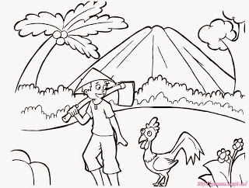  - Gambar Kartun Berwarna (Color Cartoon Images)  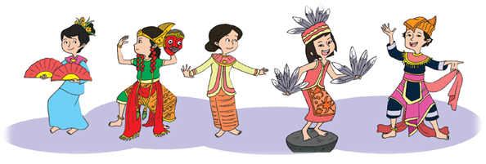  - Gambar Nyata (Real Pictures)  